MID- TERM TEST – NO 02
READING AND WRITING (50 marks)
Time allowed: 70 minutes
Part 1. Questions 1-5 (2.5 marks)
Which notice (A-H) says this (1-5)? Mark the correct letter A-H on your answer sheet.
- Children pay less than adults here.  - Be careful because this will burn.  - We don’t want any money yet.  - Things are cheaper here.  - You must pay with cash. | 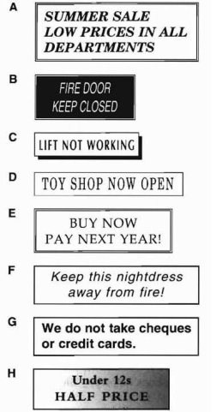

Part 2. Questions 6-10 (2.5 marks)
Read the sentences about Sam’s new computer. Choose the best word (A, B or C) for each space.
6 He………………. Sam how to it.
A learnt B showed C studied
7 Sam sent an e-mail ……………….. to his friend Billy to tell him about his nice present.
A message B programme C form
- Billy came to Sam’s house and they did their geography ………………… together.
A subject B homework C class
- They were……………….because they found some information about rivers on the internet.
A happy B interesting C pleasant
- Afterwards, they ………………… playing a new computer game together.
A wanted B thanked C enjoyed

Part 3. Questions 11-15 (2.5 marks)
Choose A, B or C to complete the five conversations.
11 How did you go to Madrid? | A On Wednesday.  B By plane.  C It’s expensive.
12 I really must go now! | A How long is it?  B Can’t you stay?  C What time?
13 Is Mike still doing his homework? | A Yes, he does.  B It’s ready  C Let’s ask him.
14 I can’t understand this letter. | A Would you like some help?  B Don’t you know?  C I suppose you can.
15 Are you sure the film starts at 10? | A Yes, I am.  B No, I didn’t.  C Yes, I do.

Questions 16-20 (2.5 marks)
. What does Sally say to the journalist? For the question 16 – 20, mark the correct letter A-H on the answer sheet.
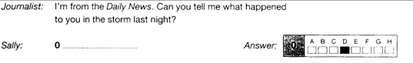
Journalist: When did the thunderstorm start?  Sally: 16.......................................................  Journalist: And when do you usually go to bed?  Sally: 17.......................................................  Journalist: So before you went to sleep, you heard a noise in the garden?  Sally: 18.........................................................  Journalist: Were you afraid?  Sally: 19.........................................................  Journalist: And how old was the tree?  Sally: 20........................................................  Journalist: Well, it’s an interesting story. Thanks for talking to me. | A. That’s right, I did. I ran out and saw a tree fall on the house.  B. When I was tired, yes.  C. At eleven most nights.  D. If you like. What do you want to know?  E. That’s the sad thing. It’s been in the garden for about two hundred years and many birds lived in it.  F. I’m not sure, but it was after I went to bed.  G. I don’t know. About ten minutes.  H. I was at first, until I saw nobody was hurt.
Part 4. Questions 21-27 (7 marks)
Read the article about the sport of Canada Geese. Choose A, B or C for the best answer.
Canada Geese
Canada geese are large blue and white birds. When autumn arrives, they have to fly south where the weather is warmer. The winters are so cold in Canada that the birds die if they stay there.
Last spring, Bill Lishman found sixteen young Canada Geese on his farm. They had lost their parents. Bill thought.” These young birds won’t know what do do in the autumn.”
Bill had a small plane and he decided to teach the birds to follow him. All through the summer, he went on short trils in his plane and the young geese flew after him.
When the cold weather arrived in autumn, Bill flew to Virginia in the United States, 600 miles south of his home in Canada. The geese followed him all the way. Bill left the geese in Virginia and he returned home.
This spring, Bill was waiting for the birds to come back. They didn’t arrive, so Bill flew to Virginia to get them. He looked for them for two weeks but he couldn’t find them.
When he arrived back home, Bill found the geese waiting for him. They had found their way home without him!

21 Bill Lishman is a farmer.
A Right B Wrong C Doesn’t say
22 Bill lives with his parents.
A Right B Wrong C Doesn’t say
23 Bill carried the geese in his plane.
A Right B Wrong C Doesn’t say
24 This was Bill’s first visit to Virginia.
A Right B Wrong C Doesn’t say
25 Bill wanted the geese to stay at his home for the winter.
A Right B Wrong C Doesn’t say
26 Bill stayed in Virginia all winter.
A Right B Wrong C Doesn’t say
27 The geese returned to Canada in the spring.
A Right B Wrong C Doesn’t say

Part 5. Questions 28-35 (8 marks)
Read information about Schnauzer dogs. Choose the best word A, B or C for each space
Schnauzer Dogs
There are three sizes of Schnauzer dog. The two smaller sizes first (28) …….. to England over 50 years ago, but the Giant schnauzer has not (29) …….. here very long. The name Giant is a good one because the dogs are 65 to 67.5 cm high.
All the dogs (30) ……..long hair, which should be cut quite often. Most smaller Schnauzers (31) …….. grey in colour, (32) …….. the Giant Schnauzer is usually black.
Schnauzers come from Germany, where farmers use the dogs to help 33) …….. with their sheep, and they are also used (34) …….. the police, because Schnauzer dogs are very intelligent.
A Schnauzer make (35) …….. nice family dog. It is friendly and very good with young children.

28 A came B come C comes
29 A being B be C been
30 A has B have C had
31 A were B is C are
32 A or B if C but
33 A them B him C us
34 A from B by C to
35 A an B a C the

Part 6. Questions 36-40 (5 marks)
Read the descriptions of some things you may learn about in a geography.
What is the word for each one? There is one space for each other letter in the word.
36 You may find snow on the top of this all times of the year  37 The farmer puts animals or plants here  38 People have to cross water to get to this.  39 The water in this starts in the hills and runs to the sea.  40 Engineers build this to take things in boats from one place to another. | m _ _ _ _ _ _ _  f _ _ _ _  i _ _ _ _ _  r_ _ _ _  c _ _ _ _

Part 7. Questions 41-50 (10 marks)
Complete the letter. Write ONE word for each space.
Dear Laura,
Would you like to come (41) …… the cinema (42) …… me after school today? We can go to see Pocahontas at the ABC cinema. The film starts (43) …… 6 o’clock. Shall (44) …… meet outside the cinema?
Love
Dear Isabella,
I am very sorry but I can’t go to the cinema (45) …… evening. My mother has (46) …… work, and I (47) …… going to cook dinner.
Why don’t you (48) …… Karen to go? I hope (49) …… like the film. You can tell me (50) …… it tomorrow.
Love

Part 8. Questions 51-55 (5 marks)
Read the travel information and the letter. Fill in the information on the application form.
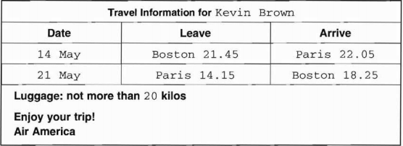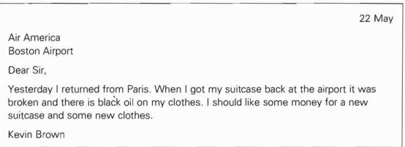

LUGGAGE REPORT FORM
Passenger’s name: Kevin Brown
Date of journey: | 51
Flying from: | 52
Time flight arrived: | 53
How much luggage did you have? | 54
What was in it? | 55

Part 9. Questions 56 (5 marks)
You have just had a birthday. Write a postcard to your American friend about your favourite birthday present.
- What the present is
- Who gave it to you
- Why you like it
Write about 25-35 words on your answer sheet.

